|  |
| --- |
| NAME: Ayush Vinod Upadhyay  ROLL NO: I025  SAP ID: 60003220131  BRANCH: Information Technology  BATCH: 1 |

**EXPERIMENT NO – 9**

**Aim:** To implement Abstract classes and packages

**Problem Statement 1:** Write an abstract class program to calculate area of circle, rectangle and triangle.

CODE:

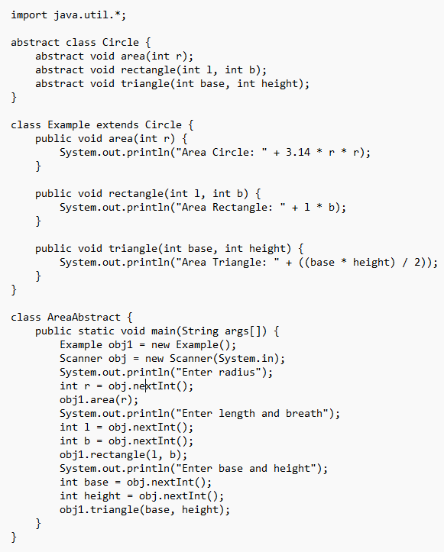

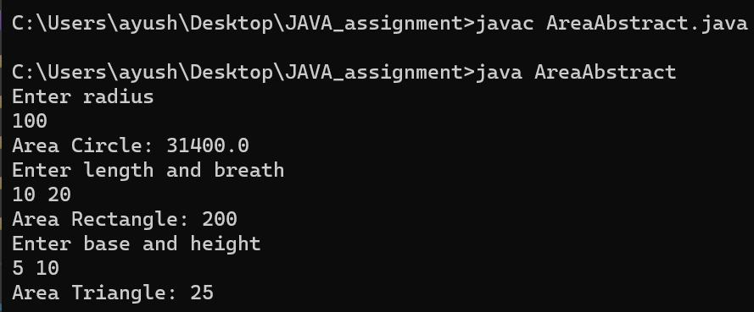

**Problem Statement 2:**

WAP to create a package called vol having Cylinder class and volume (). WAP that imports this package to calculate volume of a Cylinder.

